Project Design Phase-II

Data Flow Diagram & User Stories

|  |  |
| --- | --- |
| Date | 03 October 2022 |
| Team ID | PNT2022TMID45269 |
| Project Name | Project - xxx |
| Maximum Marks | 4 Marks |

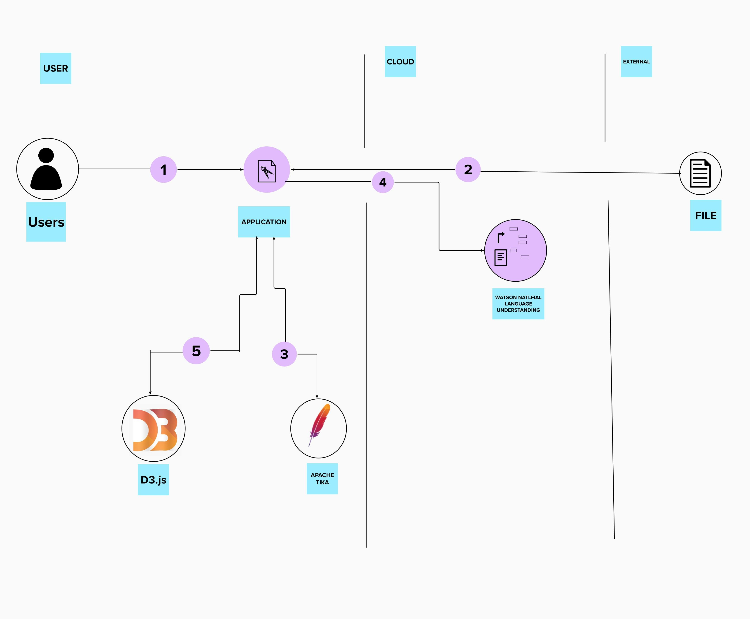

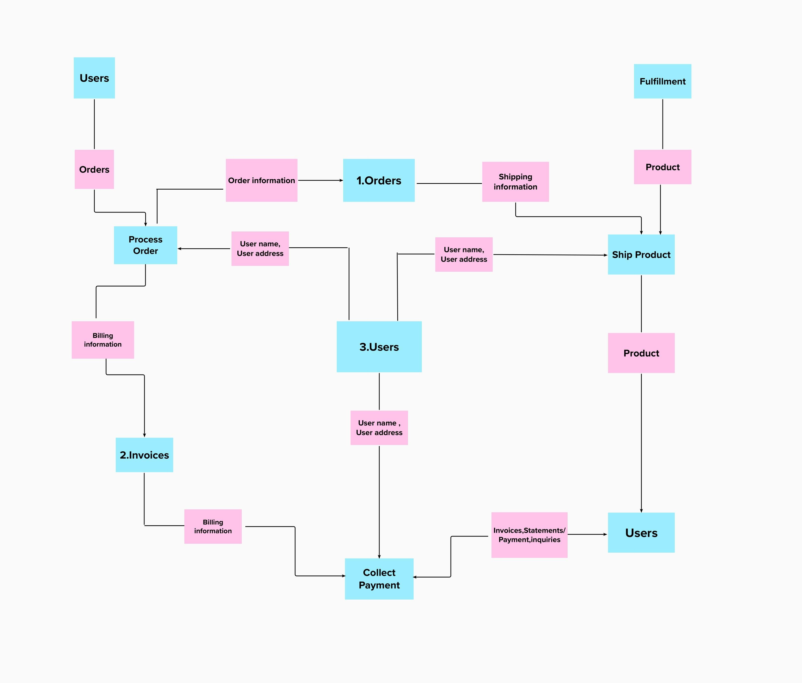

|  |  |  |  |  |  |  |
| --- | --- | --- | --- | --- | --- | --- |
| **User Type** | **Functional Requirement**  **(Epic)** | **User Story**  **Number** | **User Story / Task** | **Acceptance criteria** | **Priori ty** | **Release** |
| Customer (Mobile user) | Registration | USN-1 | As a user, I can register for the application by entering  my email, password, and confirming my password. | I can access my account / dashboard | High | Sprint-1 |
|  |  | USN-2 | As a user, I will receive confirmation email once I have registered for the  application | I can receive confirmation email & click  confirm | High | Sprint-1 |
|  |  | USN-3 | As a user, I can register for the application through Facebook | I can register & access the  dashboard with Facebook Login | Low | Sprint-2 |
|  |  | USN-4 | As a user, I can register for the application through Gmail | I can receive confirmation Gmail & click confirm | Mediu m | Sprint-1 |
|  | Login | USN-5 | As a user, I can log into the application by entering email & password | I can receive confirmation email & click confirm | High | Sprint-1 |
|  | Dashboard |  |  |  | High | Sprint-1 |
| Customer (Web user) |  | USN-6 | As a user, I can able to take up the skill assessment and view the appropriate test score. Based on the skill sets I can able to get personalised job recommendations. | I can receive job recommendatios | High | Sprint-1 |
| Customer Care Executive |  | USN-7 | As a customer care executive, we provide 24/7 chatbot support. | 24/7 chatbot support | High | Sprint-1 |
| Administrator |  | USN-8 | As an administrator, I can able to view the  progress and make required changes in the  project | Deploy user specific and personalised job recommendatios | High | Sprint-1 |
|  |  |  |  |  |  |  |
|  |  |  |  |  |  |  |
|  |  |  |  |  |  |  |